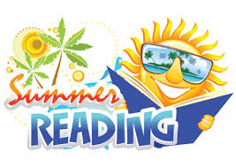 2019-2020

Students that will be in grades 4-8 have one title that all students will read, and they will choose one title from a grade level choice list for a total of two books.
The books will not be available for purchase through the school, but our lists will be sent to the public library and local book vendors. All titles are also available on Amazon.com.
All AR quizzes taken this summer will count toward the first quarter goal. It is not mandatory for students to take AR tests in the summer. The student can take AR tests on their summer books when they return to school in August.
AR Summer Dates
June 28th 7:00 a.m. – 2:00 p.m.
July 12th 7:00 a.m. – 2:00 p.m.
Maximum 5 tests per student
4th grade All students must read
Tales of a Fourth Grade Nothing by Judy Blume
Students also choose 1 from the following list.
Henry and Ribsy: by Beverly Cleary
Socks :by Beverly Cleary

The Chocolate Touch: by Patrick Cutling

I Survived Hurricane Katrina: by Lauren Tarshis

5th grade All students must read
Holes by Louis Sacher
Students also choose 1 from the following list.
Wonder by R.J. Palacio
Hoot by Carl Hiassen
Ratscalibur by Josh Lieb (LYRC)

