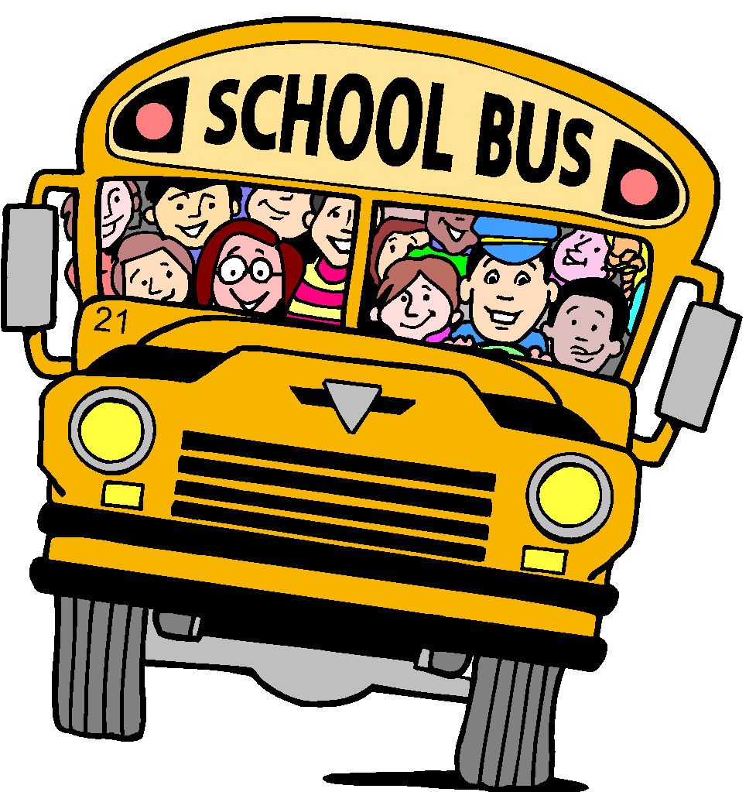
Transportation

General Information:
- Please remember that all procedures are in place for the safety of all students.
- All students are dismissed at 2:35 p.m.
- The latest the office can accept a change in transportation is 1:30 p.m.
- Students are not allowed to ride the bus to or from another student’s home.
Carpool Procedures:
- All vehicles must follow the designated carpool route.
- Cutting in line is not allowed. Please be courteous and respectful to all drivers.
- All vehicles must have a St. Joseph hang car tag to pick up a student.
Bus Procedures:
- St. Joseph students who live within the Ponchatoula School District may ride the public school buses.
- Students who ride the buses must have the appropriate bus form/s completed, signed and turned into the school office. These forms can be printed from the SJS website or hard copies are available in the office. (The office staff will give the bus driver a copy)
- Before a student can be dropped off at any address on a regular basis other than his/her home address, a “Special Request Bus Form” must be completed and have prior approval by Tangipahoa Parish School System Department of Transportation.
Walker Procedures:
Only students who live within the immediate area of the school or have a caretaker that lives within the immediate area of the school and have a “Walker Permission Form” on file in the school office may be walkers on a regular basis. These forms must be approved by administration.
- Students will be escorted by a teacher and released to a parent/adult in the designated area for walkers to exit the campus. Walker tags with current stickers must be present to claim the student.

